Churn Analysis — Summary Report
Prepared by: [Your Name] | Dataset: Telco Customer Churn | Tools: SQL, Power BI | 2024
Purpose
To identify the main reasons customers are leaving and to recommend actions the business can take to reduce churn and recover lost revenue.
Key Numbers
Metric | Value
Total Customers | 7,032
Churned Customers | 1,869
Overall Churn Rate | 26.58%
Monthly Revenue Lost (MRR) | $139,130
Annual Revenue Lost | $1,669,560
Avg. CLV – Active Customers | $2,555
Avg. CLV – Churned Customers | $1,531
What the Data Shows
- 26.58% of customers have churned. Industry average for this type of business is 5–7%, so churn is significantly higher than expected.
- Month-to-month contract customers churn at 42.71%. One-year is 11.28% and two-year is only 2.85%. Contract type is the biggest driver of churn.
- 47.68% of customers who have been with the company for 0–12 months have churned. Churn drops sharply after the first year.
- Electronic check users churn at 45.29% compared to 15–17% for customers on automatic payments.
- Churned customers have a lower average lifetime value ($1,531) compared to active customers ($2,555), meaning they also spent less during their time with the company.
Recommendations
- Offer a discount (15–20%) to month-to-month customers who switch to an annual plan. Focus on customers in their first 3–9 months.
- Set up a simple onboarding process for new customers — a check-in at month 1, month 3, and month 6 to reduce early dropout.
- Give a small monthly discount to customers who switch to automatic payments (bank transfer or credit card).
- Create a high-risk customer list: month-to-month contract + electronic check + under 12 months tenure. Contact these customers before they leave.

SQL Query Results
Results from MySQL Workbench queries run on the raw dataset.
Query 1 — Overall Churn Rate
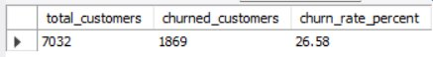
Query 2 — Churn by Contract Type
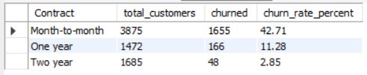
Query 3 — MRR Lost
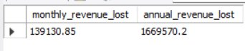
Query 4 — Churn by Tenure Group
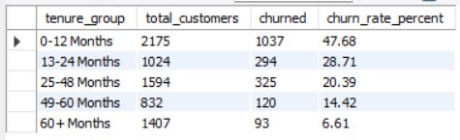
Query 5 — Churn by Payment Method
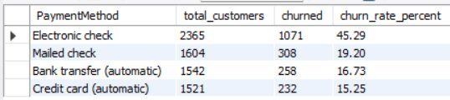
Query 6 — Average CLV
